|  |  |
| --- | --- |
| Description: cee_3line_b_4c_pc_[Converted] | [Description: https://confluence.cornell.edu/download/attachments/10420888/aguaclara_new_logo.jpg](file:///C:\Documents%20and%20Settings\mas352\Desktop\Final%20Designs\DesignSpecs\aguaclara.cee.cornell.edu) |

PRELIMINARY DESIGN FOR UI.City, UI.State, UI.Country

UI.Name

UI.Organization

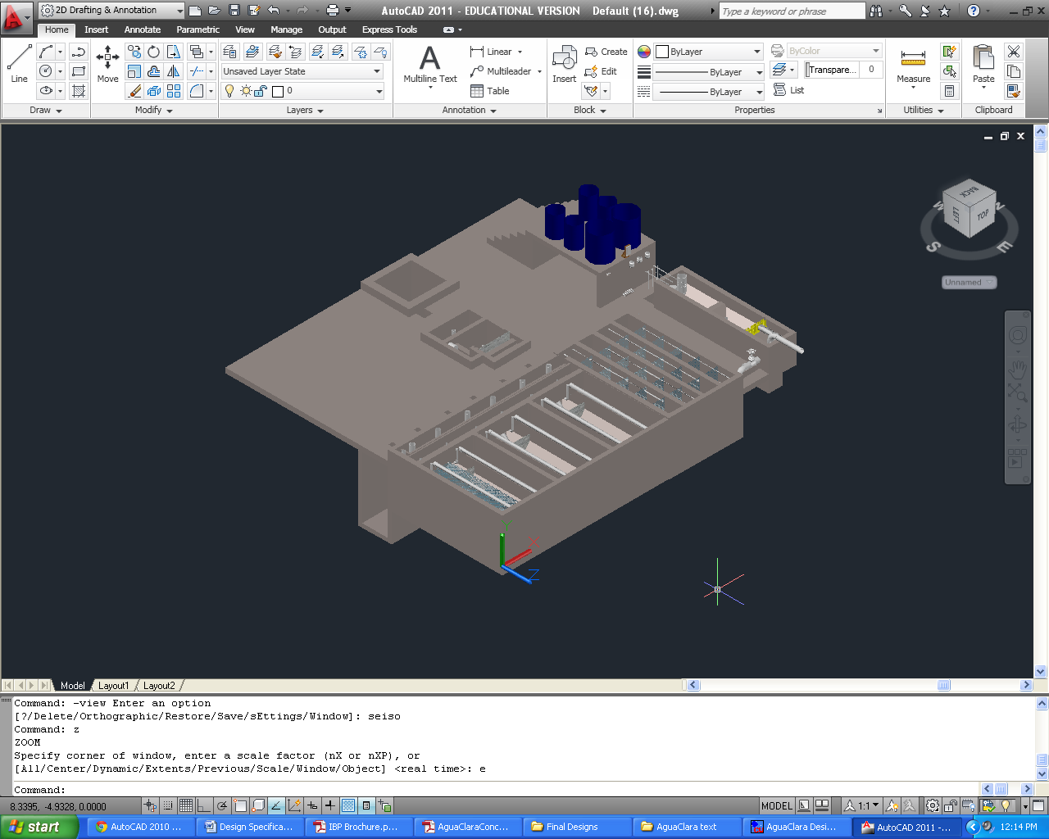

June 9, 2014 at 1:30:41 PM

Copyright © 2010 Cornell University

**Table of Contents**

[Disclaimer 4](#_Toc390084001)

[Permission and Licensing Information 4](#_Toc390084002)

[Introduction to AguaClara 5](#_Toc390084003)

[The sustainable approach 5](#_Toc390084004)

[Design Overview 7](#_Toc390084005)

[The treatment process for non-turbid groundwater 7](#_Toc390084006)

[The AguaClara Design Tool 7](#_Toc390084007)

[Plant Overview for UI.CITY 7](#_Toc390084008)

[Plant Components 8](#_Toc390084009)

[Entrance Tank 8](#_Toc390084010)

[Linear flow orifice meter (LFOM) 8](#_Toc390084011)

[Chemical dose controller (CDC) 9](#_Toc390084012)

[CDC: Design Specifications 12](#_Toc390084013)

[CDC: Calibration and Operation 13](#_Toc390084014)

[Chemical storage tanks 14](#_Toc390084015)

[Rapid Mix 16](#_Toc390084016)

[Materials List 16](#_Toc390084017)

[Entrance Tank 16](#_Toc390084018)

[Linear Flow Orifice Meter 16](#_Toc390084019)

[Chemical Dosing System 16](#_Toc390084020)

[Chemical Storage Tanks 16](#_Toc390084021)

[Overall Plant 16](#_Toc390084022)

|  |  |
| --- | --- |
| Description: cee_3line_b_4c_pc_[Converted] | Description: https://confluence.cornell.edu/download/attachments/10420888/aguaclara_new_logo.jpg  <http://aguaclara.cee.cornell.edu/>  Dr. Monroe Weber-Shirk, Director |

This preliminary design was requested by UI.Name.FirstUI.Name.Last on behalf of UI.Organization. The design was created on June 9, 2014 at 1:30:41 PM by the AguaClara Design Server at Cornell University. The design is for UI.CityUI.State, UI.Country and has a design flow rate of Q.Plant. The design was created with MathCAD code version SVN.Version.

This design is the result of over 20,000 hours of undergraduate, graduate, and faculty labor. The design incorporates advanced fluid dynamics analysis to ensure easy backwash during filtration. The chemical feed system is based on a series of inventions by the AguaClara team that make it possible to directly set the desired chemical dose and to maintain that dose automatically even as the flow rate through the plant varies..

The economic value of this design is approximately 10,000 USD. This estimate is based on the amount of time that would be required to create this design if an environmental engineering firm used the AguaClara design algorithms, but not the automated design tool, to create this design. The AguaClara team is committed to continue providing this design service because we want to encourage new implementation partners to explore the use of this technology. We also recognize that high design costs would prevent this technology from being available to small communities. However, we do require funding to maintain our design team and to continue to integrate improvements into our designs. We recommend that implementation partners include a design fee for the AguaClara design service in the project budget. The nominal fee (far below its true value) for use of this design service is 1000 USD per L/s of plant capacity. You are welcome to create multiple designs for each facility that you intend to construct to obtain an optimal plant configuration. This fee, which will guarantee continued technical support from the AguaClara team, can be paid to AguaClara by check or [online to Cornell University](http://sites.google.com/site/cuaguaclara/donate). This fee will likely be between 1% and 2% of the overall project cost for a water treatment plant. Thank you for your support.

##### Donate by Check

Make the check to Cornell University

Write AguaClara in the memo field

Mail to: AguaClara, 220 Hollister Hall, Cornell University, Ithaca, NY 14853

# Disclaimer

This document is a DRAFT. It has not been reviewed for official release. It is included with the design files to show what we plan to deliver in the near future.

This design, including the files accompanying this document, is only a draft and must be reviewed and approved by a licensed engineer prior to construction. If you have questions about this design please contact the AguaClara design team at Cornell University at [CUAguaClara@gmail.com](mailto:CUAguaClara@gmail.com).

### Permission and Licensing Information

Copyright © 2010 Cornell University

Authors: The AguaClara team at Cornell University under the supervision of Dr. Monroe Weber-Shirk

This design was created using the open source engineering services of the AguaClara program at Cornell University. It is subject to the [Creative Commons Attribution-ShareAlike 3.0](http://creativecommons.org/licenses/by-sa/3.0/us/legalcode) United States license. If you alter, transform, or build upon this work, you may distribute the resulting work only under the same, similar or a compatible license.

Permission to use this AguaClara Design Tool along with the subsequent AutoCAD renderings and supporting files for design specifications provided by Cornell based on your input parameters (collectively "WORK") and their associated copyrights without a written agreement is hereby granted. Any water treatment plants built using this WORK shall be designed and supervised by a licensed civil engineer.

IN NO EVENT SHALL CCTEC, CORNELL UNIVERSITY, OR THEIR EMPLOYEES BE LIABLE TO ANY PARTY FOR DIRECT, INDIRECT, SPECIAL, INCIDENTAL, OR CONSEQUENTIAL DAMAGES, INCLUDING LOST PROFITS, ARISING OUT OF THE USE OF WORK AND ITS ASSOCIATED COPYRIGHTS, EVEN IF CCTEC OR CORNELL MAY HAVE BEEN ADVISED OF THE POSSIBILITY OF SUCH DAMAGE.

THE WORK PROVIDED HEREIN IS ON AN "AS IS" BASIS, AND CCTEC, CORNELL, AND THEIR EMPLOYEES HAVE NO OBLIGATION TO PROVIDE MAINTENANCE, SUPPORT, UPDATES, ENHANCEMENTS, OR MODIFICATIONS. CCTEC, CORNELL, AND THEIR EMPLOYEES MAKE NO REPRESENTATIONS AND EXTEND NO WARRANTIES OF ANY KIND, EITHER IMPLIED OR EXPRESSED, INCLUDING, BUT NOT LIMITED TO, THE IMPLIED WARRANTIES OF MERCHANTABILITY OR FITNESS FOR A PARTICULAR PURPOSE, OR THAT THE USE OF WORK AND ITS ASSOCIATED COPYRIGHTS WILL NOT INFRINGE ANY PATENT, TRADEMARK OR OTHER RIGHTS.

Users of WORK shall indemnify, hold harmless and defend Cornell, its officers, employees, agents, and the sponsors of the research that let to WORK against any and all claims, suits, losses, damage, costs, fees, and expenses resulting from or arising out of use of WORK. This indemnification shall include, but not be limited to, any product liability. Users of WORK, at their sole cost and expense, shall sufficiently insure their activities in connection with the WORK and obtain, keep in force, and maintain insurance or an equivalent program of self insurance. Cornell shall notify users of WORK in writing of any claim or suit brought against Cornell in respect of which Cornell intends to invoke the provisions of this paragraph. Users of WORK shall keep Cornell informed on a current basis of its defense of any claims under this paragraph.

# Introduction to AguaClara

## The sustainable approach

AguaClara is a program in Civil and Environmental Engineering at Cornell University that is improving drinking water quality through innovative research, knowledge transfer, open-source engineering, and replicable design of sustainable municipal water treatment systems.

The team is directed by Monroe Weber-Shirk and has worked in Honduras in partnership with a local NGO, AguaPara el Pueblo, and in India with the Tata Foundation and the NGO Pradan. The AguaClara program received the 2011 Intel EnvironmentTech Award in recognition of the success of the program in developing sustainable technologies and effective governance models.

Cornell-designed AguaClara municipal water treatment plants are providing nine Honduran towns with populations between 1,500 and 15,000 with safe drinking water from their taps. The Agua Clara plants in Honduras produce safe drinking water with turnkey design, construction, operation, training, and transfer costs of $20 to $30 per person served and incremental operating costs of $2-$4 per person per year. The AguaClara technology is uniquely capable of producing high quality drinking water from turbid surface waters without using electricity. The facilities use gravity powered chemical dosing, hydraulic flocculation (to form large aggregates from the contaminants, or flocs), high-rate sedimentation using custom-fabricated plate settlers (to remove the flocs), stacked rapid sand filtration, and disinfection using liquid chlorine (to kill any residual pathogens that escaped the previous treatment steps). The designs rely on materials that are sourced in the community and national supply chains. The municipal water treatment plants are designed to be easy and economical to operate.

In India, AguaClara facilities use chemical dosing systems and low flow stacked rapid sand filters to treat groundwater, again, without using electricity. Where groundwater only requires disinfection, AguaClara chlorine dosers provide accurate chlorine disinfection.

Extending safe drinking water coverage to resource poor communities requires multiple engineering innovations and a new approach to implementation and governance. Our robust technologies do not require electricity or external power sources. Our governance model is based on community ownership, community-based democratic governance, and technologies that are specifically designed to be easy to operate and to encourage pride in ownership. We build implementation partner capacity and intend to encourage the formation of a network of implementation partners that will share best practices for implementation and long-term operation of community-based water treatment facilities.

This integrated model of technology development for compatibility with a sustainable governance model has proven extremely successful. All AguaClara facilities are owned and operated by their respective communities and all facilities continue to provide safe drinking water. This is particularly noteworthy in Honduras where most water treatment plants for large cities do not reliably meet drinking water standards. Several towns with AguaClara facilities are experiencing reverse migration from Tegucigalpa due to their superior water.

Democratic community governance through an elected water board has proven to be very effective and the water boards use the water tariffs (that the community has voted toincrease) to fund improvements to their water supply infrastructure. Water boards with AguaClara facilities have invested in reforestation of their watershed, upgrades to their distribution system, extensions to their distribution system to add new customers, and ongoing maintenance of the water supply infrastructure. Customer willingness to pay for safe drinking water is significantly higher than their willingness to pay for unsafe river water and the difference is greater than the increased operation and maintenance cost of providing safe drinking water using AguaClara technologies.

Our goal is to disseminate this technology and our learning regarding sustainable governance globally. The AguaClara engineering designs are shared online to facilitate technology dissemination and to reduce design costs. National engineering firms (non-profit, private, or governmental) are trained to build the water treatment facilities using locally available materials and community labor. Our partners work with locally-trusted organizations to develop a governance model that is suited to the natural resources, national governance framework and available social and human capital of a particular community.

We are seeking funding that will support our research and development work to extend the range of community sizes that can be served using the Agua Clara technologies. We haveexperience with communities between 1,500 and 15,000 and plan to extend that range inboth directions. We are researching several technologies that have the potential to reduc ethe construction and operating costs of the water treatment plants and need funding to support that effort. There are significant engineering and governance challenges as we develop approaches to community based water treatment for communities with fewer than1,500 inhabitants. Extending our design capabilities for treatment facilities that can serve larger cities is easier. The engineering and technical challenges will require developing new fabrication methods, testing prototypes for performance, and coding the new designs for dissemination via our online design tool.

We are also interested in testing models for implementation and governance. Our experience suggests that partnerships between the AguaClara team at Cornell, implementation partners, and community governance bodies realize their full potential when there is a high level of trust between the organizations and an ongoing technical assistance circuit rider. The AguaClara technologies are designed to encourage the creation of trust and self-sufficiency by being easy to understand and easy to maintain even in resource poor communities. We would benefit from experiences with different types of implementation partners and with more governance and technical assistance models to learn which approaches are most effective for various situations.

The AguaClara program overcomes the major barriers to safe drinking water that were previously encountered by small communities. We estimate that well over 100 million people living in Latin America and the Caribbean, Africa, and Asia could benefit from these technologies. The resilient design, innovative fabrication methods based on locally available materials, the automated design tool, and community based governance hold the prospect of improving the quality of life in thousands of communities in the coming years.

# Design Overview

## The treatment process for non-turbid groundwater

AguaClara plants treat non-turbid groundwater (influent water > ??? NTU) for pathogens using a chlorine-disinfection strategy. The semi-automatic chemical doser delivers chlorine to the filtered water. The chlorinated water is stored in a distribution tank to allow for sufficient contact time with the chemical, ensuring the water is fully disinfected. After disinfection, the treated water is ready for distribution to households. Water treated by the AguaClara system is consistently below 5 nephelometric turbidity units (NTU), and frequently meets the US standard for maximum turbidity, 0.3 NTU.

## The AguaClara Design Tool

In the AguaClara Design Tool (ADT), the basic design parameters requested (e.g. flow rate, wall thickness, number of sedimentation tanks desired, the dimensions of purchased lamella material, etc.) are used as variables in a series of hydraulic and geometric algorithms that define the dimensions of the plant reactors and their accessories. The design algorithms in the ADT are based on fundamental physics, and thus are scalable over a wide flow range. Algorithms have been revised and constrained based on lab research and feedback from the field to ensure both efficient material usage and ease of operation. The software output based on these parametric algorithms is a three-dimensional drawing in AutoCAD of each reactor that is to be given to the designer. The designer completes the design based on the ADT output by adding the final treatment components, the plant building, and distribution system, and then the designer must perform a full structural analysis of the plant. This document provides a summary of AguaClara processes with regard to the design of closed facilities. Consequently, all calculated values (e.g. lengths of plant reactors, distances between the centers of the orifices, etc.) are specific to this plant design, and do not necessarily apply to other AguaClara plants.

## Plant Overview for UI.CITY

Included is the design for a plant for UI.City having a maximum flow rate of Q.PlantL/s. The design was created assuming specific input parameters, shown in Table 1 below. The software uses these parameters together with the requested flow rate as variables in a series of hydraulic and geometric calculations that define the dimensions of the various plant components. The goal of the plant with respect to disinfect the water with chlorine, and maintain a residual chlorine concentration throughout distribution between 0.3 and 1.0 mg/L. The plant treats water without using electricity, utilizing flow control and disinfection by chlorine. Table 1 shows the main parameters for the plant.

|  |  |
| --- | --- |
| **Maximum flow rate** | Q.Plant |
| **Maximum Chlorine Dose** | C.ChlorineDoseMax |
|  | |
| ?????? |  |
|  |  |
|  |  |

Table 1. General Plant Assumptions

The treatment processes have been designed according to the maximum flow rate, Q.Plant. While the resulting dimensions and layout have been cost optimized wherever possible, the user may choose to change some values if need be.

# Plant Components

## Entrance Tank

The entrance tank is a concrete rectangular tank that holds raw water and houses the LFOM which measures plant flow rate. Table 2 shows the dimensions of the entrance tank for the plant.

|  |  |
| --- | --- |
| **Entrance Tank Specifications** | |
| **Length** | L.Entrance |
| **Width** | W.Entrance |
| **Height** | H.Entrance |
| **Thickness of Concrete** | T.Entrance |

Table 2. Entrance Tank for plant in UI.City

## Linear flow orifice meter (LFOM)

The linear flow orifice meter, or LFOM, is the riser pipe found in the the entrance tank. Water exits the entrance tank through the orifices in the LFOM, is dosed with coagulant, undergoes rapid mix, and then enters the filtration system. The diameter of the pipe is set such that cross-sectional area of the pipe required is Pi.LfomSafety times the minimum area required to carry the average velocity of water in the pipe, giving aND.RMPipe in nominal diameter pipe. The additional area ensures that water free falls into the rapid mix pipe so the flow in the pipe is hydraulically disconnected from the flow through the entrance tank. The orifice pattern in the LFOM is designed to approximate the shape of a sutro weir, which forces a linear relationship between the flow rate over the weir and the head loss over the weir. The maximum head loss over the weir is set to be HL.Flowmeasure, since the sutro weir approximation is not valid at higher head losses. Assuming a B.LfomRows spacing between the rows of orifices, the theoretical flow area required in the top B.LfomRows of the LFOM can be calculated, and the orifice size is set to be no larger than that to ensure at least one orifice can be placed in the top row. This design requires D.LfomOrifices diameter orifices.

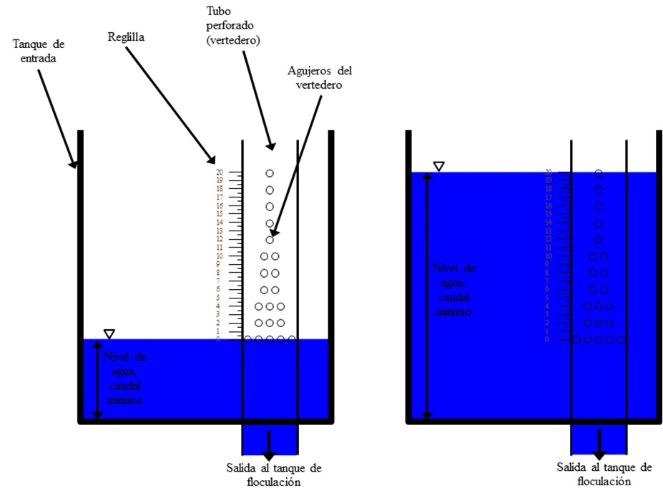

**Figure 1**: AguaClara Linear Flow Orifice Meter

The number of orifices in each row is calculated by minimizing the mean square error as compared to perfectly linearized flow. Table 2gives the orifice pattern for this specific design.

|  |  |
| --- | --- |
| **Row Height (m)** | **Number of Orifices** |
| H.LfomOrifice1 | N.LfomOrifices1 |
| H.LfomOrifice2 | N.LfomOrifices2 |
| H.LfomOrifice3 | N.LfomOrifices3 |
| H.LfomOrifice4 | N.LfomOrifices4 |
| H.LfomOrifice5 | N.LfomOrifices5 |
| H.LfomOrifice6 | N.LfomOrifices6 |
| H.LfomOrifice7 | N.LfomOrifices7 |
| H.LfomOrifice8 | N.LfomOrifices8 |
| H.LfomOrifice9 | N.LfomOrifices9 |
| H.LfomOrifice10  Table 2.The orifice pattern in the LFOM for UI.City. The row height is measured from the bottom of the orifices in the first row. | N.LfomOrifices10 |

## Chemical dose controller (CDC)

The disinfection process require precise dosage of a ​​solution of calcium hypochlorite to the plant effluent (filtered water). The CDC is hydraulically connected to the entrance tank, enabling the control system to automatically adjust the flow of chemical solution through the plant to maintain the desired dose even at varying flow rates. Chlorine from the calcium hypochlorite eliminates the microorganisms and protects against contamination in the distribution network. To carry out this process without pumps, the AguaClara plant uses a hydraulic metering system called the chemical dose controller. The main components of the system are storage drums, stock solution, an elevated platform to raise drums , chemical calibration columns, a float valve that maintains a constant liquid level, the dosing system that provides the required relationship between the pressure drop in the system and the flow of chemicals, and a scale in the inlet tank of the plant.

This system has the capacity of automatically shutting down when there is no flow in the plant, and it also changes the flow of chemicals automatically in proportion to the level of water in the inlet tank , which is linearly proportional to the flow rate of the plant due to LFOM. The first provides security against excess chemical pollution and wastage of chemicals in the event of plant shutdown without the need of manually stopping the chemical flow. The second allows an operator to select the dose easily without doing any calculations, and without manipulating the system each time the flow in the plant is changed.

Chemicals are stored in containers placed in an elevated table, from which the chlorine solution flows to a constant head tank equipped with float valves. The float valve maintains a constant liquid level in the tank, which provides a constant level which is used to control the flow of each chemical hydraulically. In this way the flow of chemical is independent of the fluid level in the storage containers. The chemical solution leaving the tank respectively flows through a flexible hose of larger diameter, where there is no significant head loss, then to a manifold that divides the flow between several straight tubing with a smaller diameter (Figure 2 ) . The system of small diameter tubing serves as the main element of head loss in the flow path, so that major losses are more critical and minor losses (expansions) are kept minimal. (The system is designed so because major losses in a laminar flow regime provide a linear relationship between flow and hydraulic head, while minor losses have a nonlinear relationship). A collector at the other end of the small diameter tubes combines flow again, and a large diameter tube leads to the metering device mounted on the tank wall of the plant.

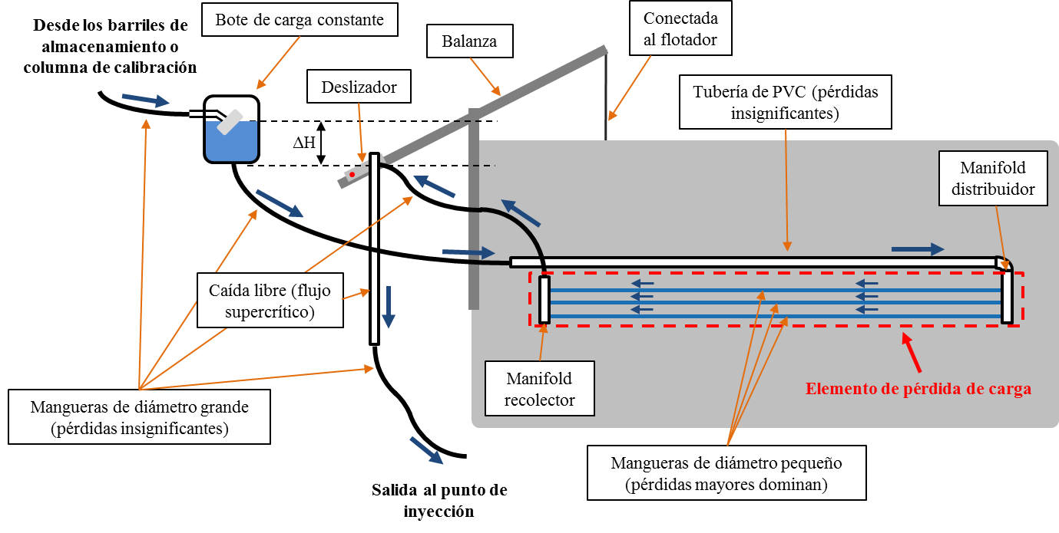

*The blue arrows indicate the path of the constant head chemical tank, small diameter pipes, and ending on the slider on the scale. The height of the outlet of the hose in the slider is what controls the chemical flow. Hence, the chemical falls in the PVC pipe and is injected into the raw water.*

***Figure 2****: AguaClara Chemical Dose Controller*

The metering device consists of lever system mounted on the tank wall. As pictured in Figure 3, a ND.EtFloat diameter float hangs from the dosing lever arm and sits in the entrance tank. The other side of the lever arm is marked with a dosing scale and has a drop tube attached to a slider. The operator moves the slider along the left side of the arm to set the desired dose. At the other end of the scale a float is attached to the inlet tank. When there is no flow through the plant, as shown in Figure 3, the dosing arm is level, and there is no head to drive the flow of chemical. When water is flowing through the plant, as show in Figure 4, the float rises along with the water level in the tank, dropping the dosing point below the elevation of the fluid level in the constant head tank, and thus providing a driving head for chemical flow.

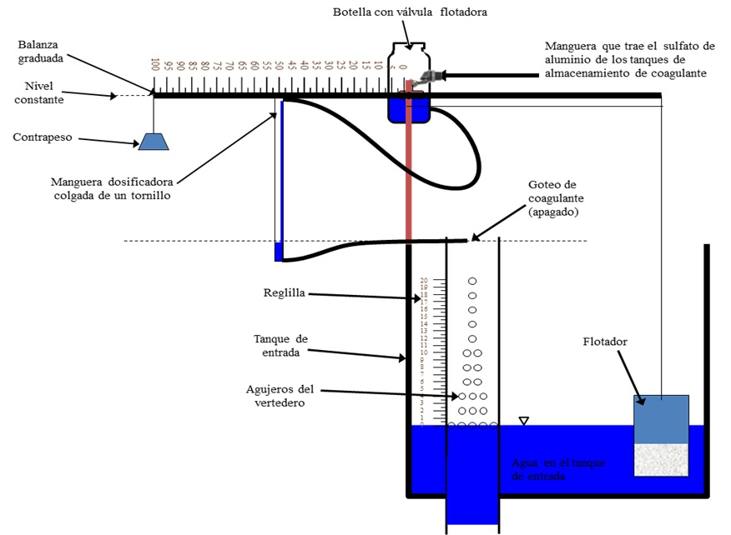

*In no flow mode, the fluid level elevation in the constant head tanks is same as that of the dosing point, meaning there will be no flow of chemical into the plant (Note that the small tubes are not shown in this diagram for clarity).*

***Figure 3****: Chemical Dose Controller at zero plant flow rate or in “no flow” configuration*

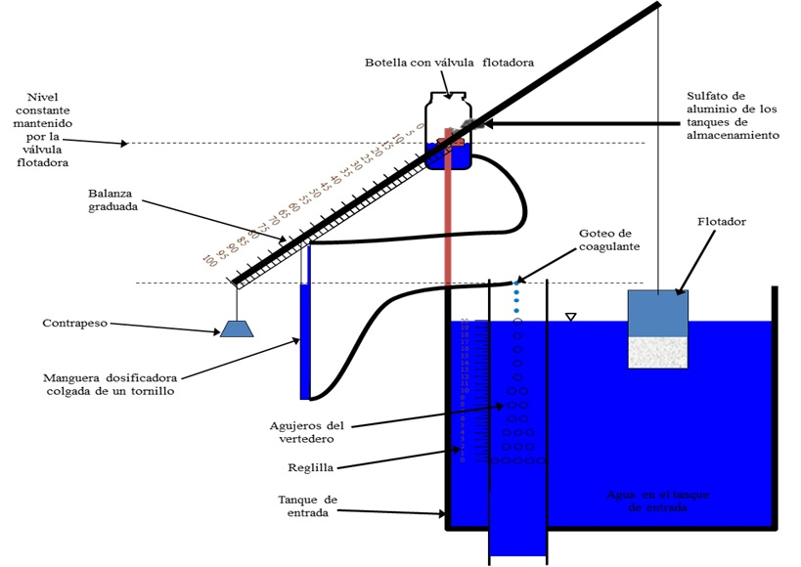

*The driving head for the chemical stock solution is given by the elevation difference between the fluid level in the constant head tank and the dosing point. Note that the slider is at the maximum dose point.*

***Figure 4****:**Chemical Dose Controller in the Operating mode*

### CDC: Design Specifications

Table 5 lists the complete specifications for the dose controllers.

|  |  |
| --- | --- |
| **Chemical Dose Controller Specifications** | |
| ***General parameters*** | |
| Chlorine Type | Calcium Hypochlorite |
| ***Chemical Concentrations*** | |
| Maximum Dose | C.ChlorineDoseMax |
| Maximum Stock Concentration | C.ChlorineStockMax |
| ***Tanks and Floats*** | |
| ET Float diameter | ND.EtFloat |
| ET Float height | L.EtFloat |
| Float valve orifice diameter | D.ChlorFloatValveOrifice |
| Stock tank to constant head tank tube diameter | D.ChlorTubeStockToCH |
| Large tube diameter (see CDC Design Alg.) | ??????????? |
| Flow Rate from Stock | Q.ChlorineStock |
| ***Lever Arm and Drop Tube*** | |
| Lever arm length (total) | L.LeverArmTotal |
| Float Arm Length | L.CdcFloatArm |
| Scale Arm Length | L.CdcScaleArm |
| Drop Tube Length | L.DropTube |
| Drop Tube Diameter | ND.DropTube |
| ***Dosing Tubes for Flow Control*** | |
| Minor loss coefficient | K.CdcTube |
| Number of Tubes | N.CdcChlorineTubes |
| Length of Tubes | L.CdcChlorineTube |
| Diameter of Tubes | D.CdcChlorine |
| Maximum head loss through small-diameter tubing | HL.CdcChlorine |

Table 5.Chemical dose controller design for UI.City.

### CDC: Calibration and Operation

When there is no flow through the plant, as shown in Figure 3, the dosing arm is level, and there is no head to drive the flow of chemical. When water is flowing through the plant, the float rises along with the water level in the tank, dropping the dosing point below the elevation of the fluid level in the constant head tank, and thus providing a driving head for chemical flow. This situation is pictured in Figure 4. To decrease the chemical dose, the operator needs to move the slider to the desired dose marked on the scale of the level arm. With the slider moved further to the right, the dosing point elevation does not decrease as much as the float rises, and so the driving head – and thus the chemical flow – decreases.

Recall that the water height in the entrance tank changes linearly with the flow rate going through the plant due to the LFOM. Similarly, the flow of chemical stock solution is linearly related to the elevation difference between the fluid level in the constant head tanks and the dosing point. The linear relationship between the driving head of the chemical and the chemical flow rate is established by designing the dosing tubes such that the head loss is dominated by major(shear) losses. The lengths of the dosing tubes are limited by the need to have the tubes drape without hitting the floor.

For the doser to function optimally, it is crucial for each component to be installed correctly. To properly calibrate the doser once it has been mounted to the entrance tank, the no flow situation needs to be simulated in the entrance tank (Figure 3) by draining the tank until its water level is just below the bottom of the LFOM’s bottommost row of orifices. Then, with the lever arm perfectly horizontal, adjust the length of the rope attached to the float so that the float sits exactly vertically. With the lever arm in the horizontal position, mount the constant head tank such that its fluid level is at the same elevation as the dosing point. Then, fill the entrance tank until the water height corresponds to the maximum flow rate (where the topmost orifices of the LFOM are just submerged, as in Figure 4). The elevation of the maximum dose point on the scale should have decreased by the maximum allowable head loss for the chemical. Position the slider to an intermediate dose, because this method leaves extreme flow rates less susceptible to calibration errors.)At the intermediate dosing position, measure the flow of chemical through the dosing tube and compare it to the theoretical flow rate, which can be calculated by rearranging Eq 2 as follows:

Eq 7.

where hf is given by the elevation difference between the dosing point and the fluid level in the constant head tank. If the flow rate is greater than the theoretical, cut the tube and repeat the test until the theoretical value matches the measured value. If the flow rate is less than the theoretical, a longer tube must be obtained and the calibration must begin again from the first step. Once the theoretical and measured values match, the doser is ready for use.

In addition to good calibration, the doser must be periodically cleaned for good performance. Any sediment that may be clogging the valves or fittings must be cleaned out to prevent underdosing. Additionally, air bubbles in the tubes will cause dosing errors. If bubbles are present, remove the tube from the dosing system and force the bubbles out.

## Chemical storage tanks

There are two calcium hypochlorite tanks on the stock tank platform. The design of the chemical storage tanks is based on the tank volumes available for purchase locally and it is assumed that the stock tank will be refilled no more frequently than once every Ti.ChlorineStock. In order to determine the required volume of a chemical tank, the maximum chemical flow rate, QChemStockMax, must first be determined as follows:

Eq8

where CChemDoseMax is the maximum allowable chemical dose, and CChemStockis the stock concentration in the chemical tank. Using the maximum chemical flow rate, the volume of the stock tank, VolChemTank,is computed using the following formula:

Eq9

For plants that require stock tank volumes slightly larger than the nearest available tank volume, the ADT automatically rounds down to the nearest desired volume to make the size as small as possible. Specifications for this particular stock tank design are given in Table 6 below.

The vertical position of the coagulant tank must be high enough to provide enough hydraulic head to achieve the desired maximum chemical flow rate through the float valve orifice entering the constant head tank. This distance is given by H.CoagTankAboveHeadTank, and is added to the elevation of the water level in the constant head tank to find the elevation of the stock tank outlet.

All of the piping required to administer the dose and drain the stock tanks (Figure 5) uses a nominal diameter of ND.CoagPiping. The piping that connects to the constant head tanks begin at a bulkhead fitting set at an elevation of B.StockOutlet higher than the bottom of the stock tanks to prevent sediment from entering the pipes.



**Figure 5**: Chemical Stock Tanks

.

|  |  |
| --- | --- |
| **Stock Tank Specifications** | |
| Turnover time for the chlorine stock | Ti.ChlorineStock |
| Dose and drain plumbing size | ND.CoagPiping |
| Chlorine tank volume | Vol.ChlorineTank |
| Height of stock tanks above constant head tanks | H.CoagTankAboveHeadTank |

Table 6.Chemical storage tank design for UI.City.

## Rapid Mix

Once it has been dosed with coagulant, the water passes through the rapid mix system. Rapid mix serves to uniformly distribute the coagulant through the raw water. In this plant, the rapid mix occurs as turbulent flow through a pipe with an inner diameter of ND.RMPipe. This pipe brings water from the point at which coagulant is dosed to the filters.